AUTH-003
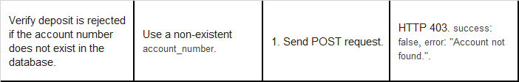
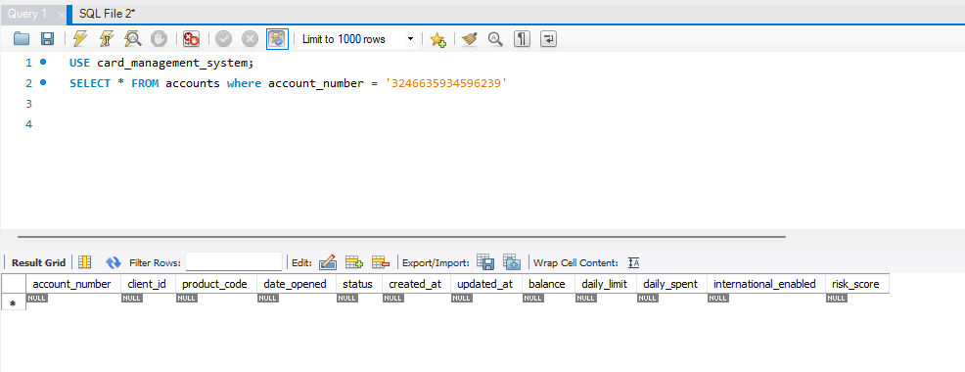
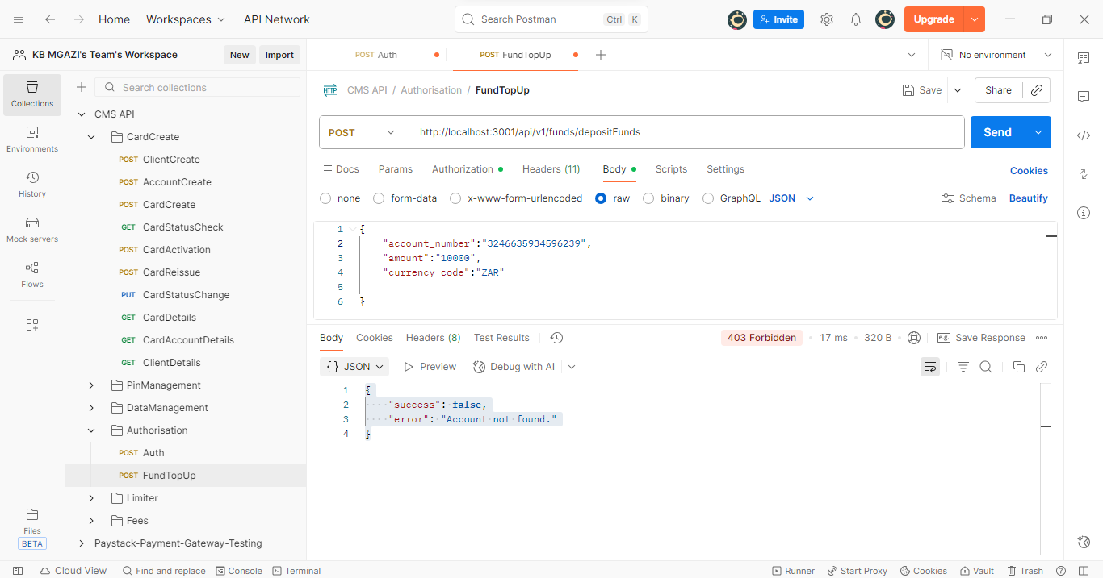
Request:
{
"account_number":"3246635934596239",
"amount":"10000",
"currency_code":"ZAR"

}
Response:
{
"success": false,
"error": "Account not found."
}

